SQLA1 Exercise – Daniel Hutchins – CIS 310-01

* Running Use CIS31043 command to use CIS31043 database in SQL Server.

* Representation of all table structures created from the KIMTAY_DB_SCRIPT.sql file.
  + SALES_REP table includes key information to locate sales representatives for KimTay Pet Supplies.
  + ITEM table includes detailed information of products on sale with inventory available at KimTay Pet Supplies.
  + CUSTOMER table includes specific information regarding customers of KimTay Pet Supplies.
  + INVOICES table includes essential information to tie invoices to customers of KimTay Pet Supplies.
  + INVOICE_LINE table includes detailed information of transactions conducted at KimTay Pet Supplies.

* CUSTOMER table created in CIS31043 SQL Database.

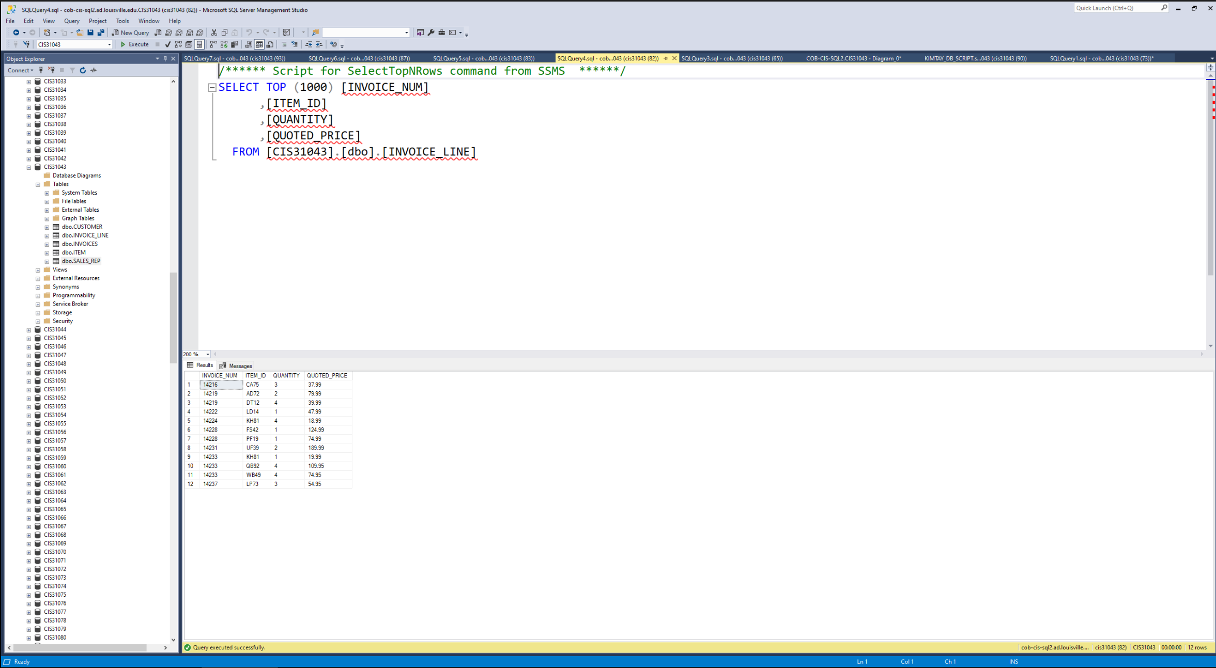

* INVOICE_LINE table created in CIS31043 SQL Database.

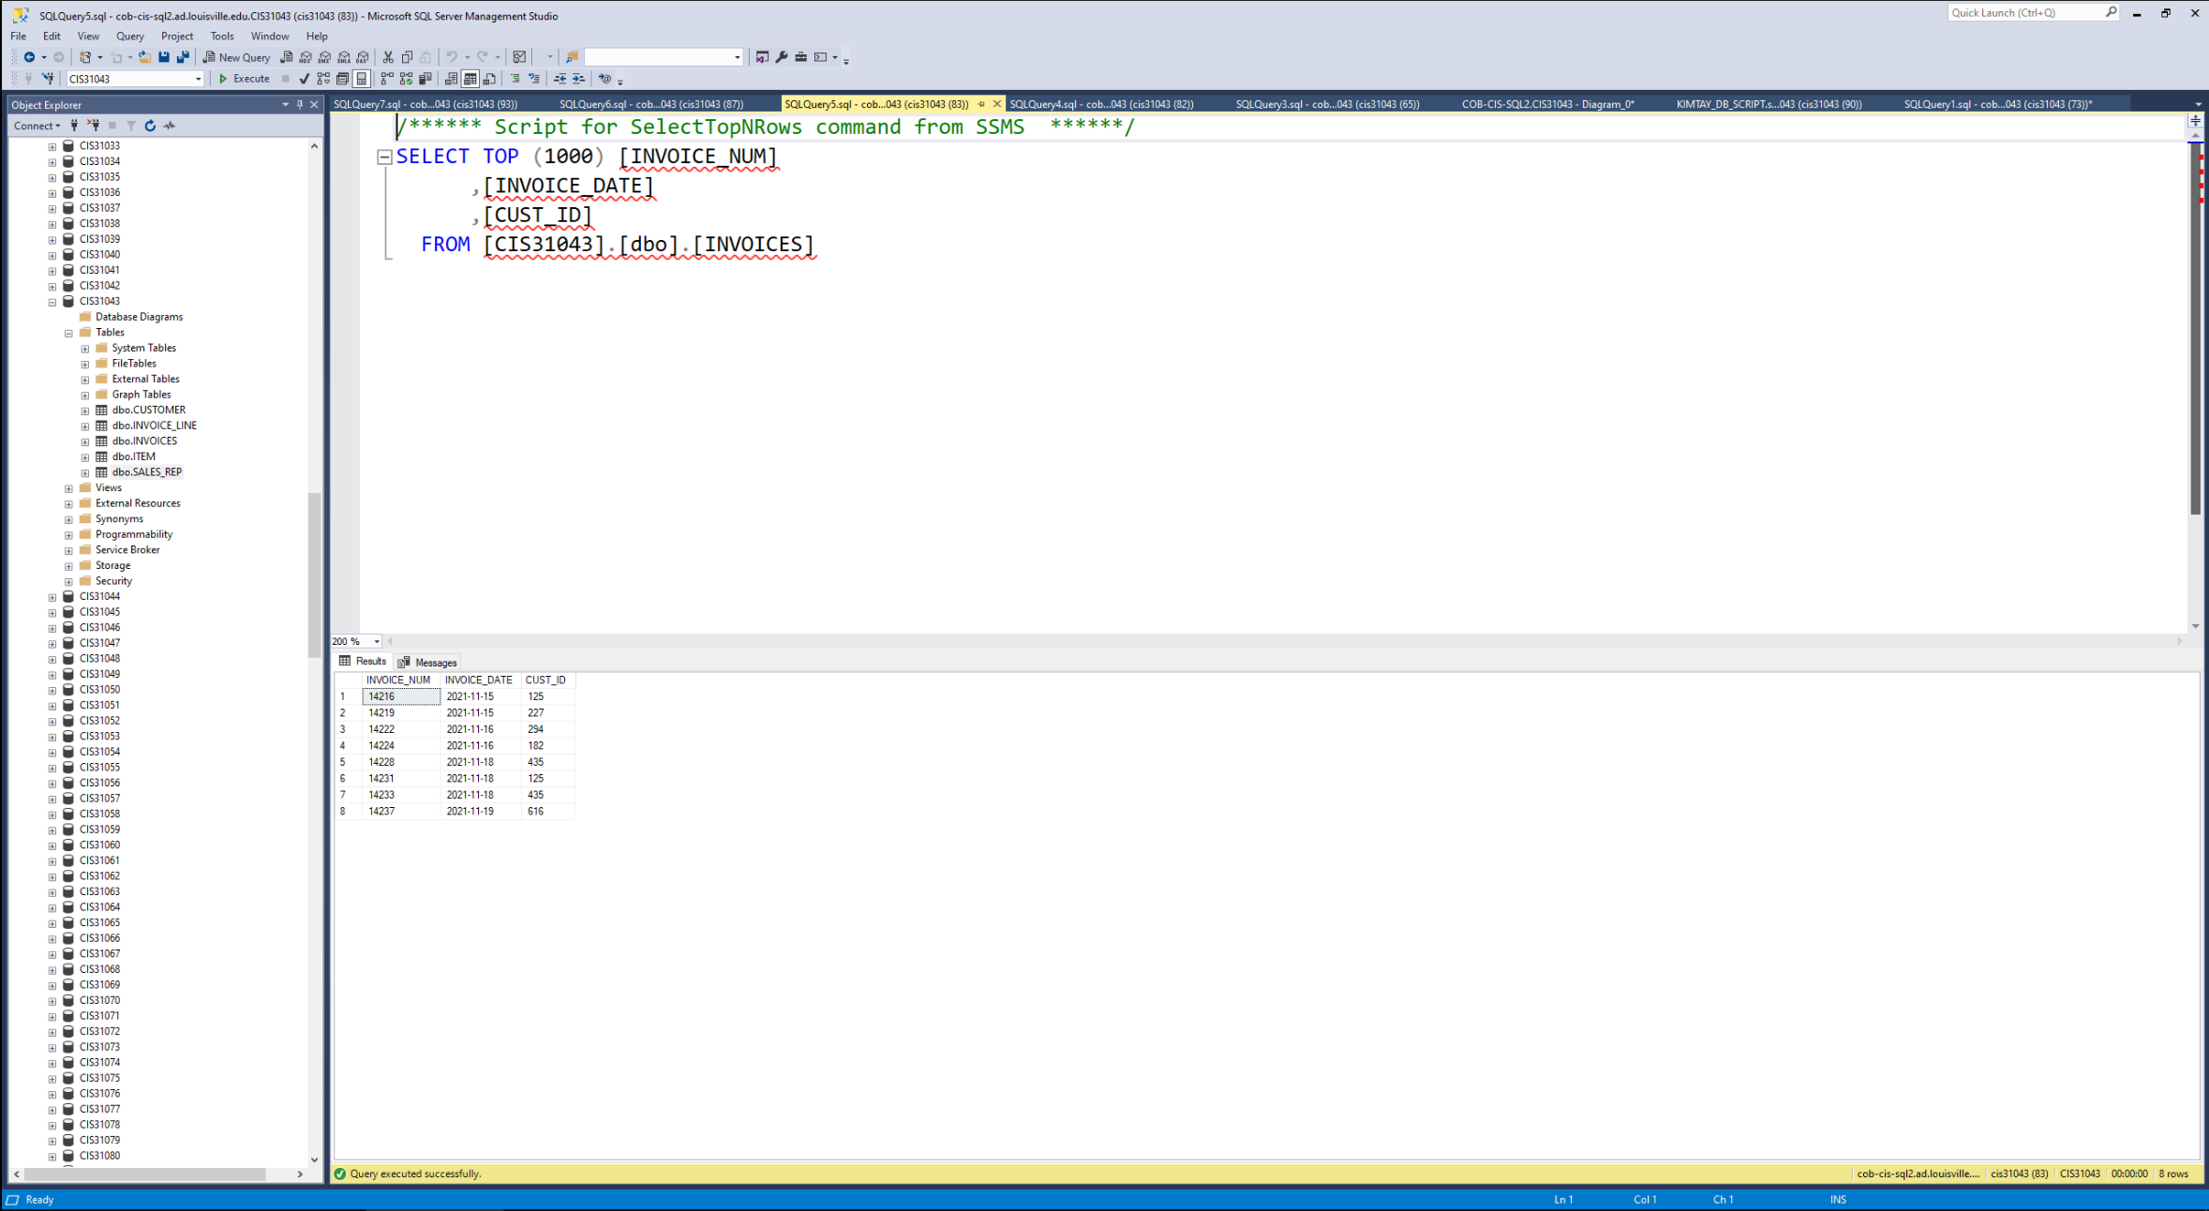

* INVOICES table created in CIS31043 SQL Database.

* ITEM table created in CIS31043 SQL Database.

* SALES_REP table created in CIS31043 SQL Database.